Colorado Scholastic State Chess Championship Tournament

By Jackson Chen

On February 16, 2008, over 300 kids went to Tivoli Center, Denver, to compete for the scholastic state championship. There were four divisions: K-3, 4-6, 7-9, and 10-12. The top player’s games from each division are live broadcasted into the projecting room, so that parents and other players can watch. Famous chess players commentate the top players’ games. The tournament lasted for two days. Every year, Tivoli Center hosts this state scholastic championship tournament.

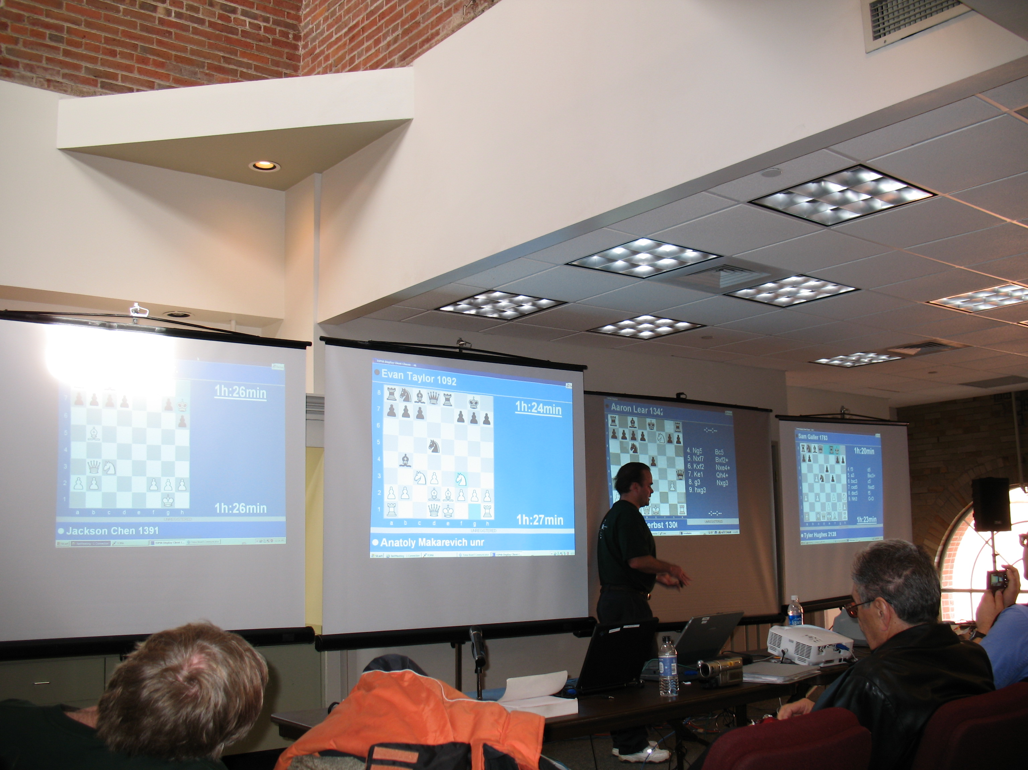

Two years ago, 200 kids participated the tournament. Last year, 250 kids joined the tournament. This year, 6 High Peaks students participated in the tournament. They are: Gaylen Davis and Ryan Swerdlin from 2nd grade; Katherine Chen and Jackson Chen from 4th grade; Casey Davis, Anatoly Makarevich and Jesse Zhang from 5th grade.

Ryan Swerdlin won first place in the K-3 division. Anatoly Makarevich and Jackson Chen won the championship in the 4-6 division. Other High Peaks participants did well, too. As a result, High Peaks won the 4-6 team championship.

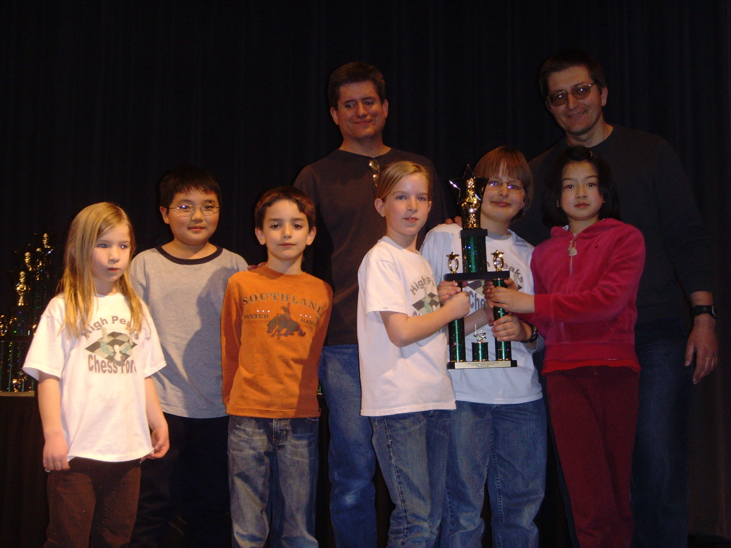
The tournament was also a fun event. During the tournament, there was a food court filled with fast food restaurants and a chess shop have sold varieties of chess boards, chess pieces, chess key chains, chess shirts, chess books, and chess software programs.

The tournament also had an especially interesting activity: a chess puzzle contest. It is where players have to solve ten chess puzzles. The grand prize won an iPod nano. First place winner gets a chess software. Second place winner gets a mini chess set. Anatoly Makarevich won the first place in 4-6 division.

After each player’s games or between games, some players played entertainment chess games outside of the chess tournament hall. There are team rooms where team members meet and analyze their own games. Other players were having snack, talking, or watching the live broadcasted games. It was a good opportunity to make friends.

The parents also had a lot of fun, too. Some of them chat with each other. Some other parents watched the live broadcasted games. Other parents play games with their kids players. Tivoli Center provides computers where kids and their parents can use it for checking emails and playing computer games.

Participants of the chess tournament have to play six round games in two days. After all the players finish their six rounds, award ceremony begins. Top ten ranked players in each division get trophies. And top three ranked teams get trophies. All the trophies are shiny, and beautiful.

After the tournament, the result, the ratings, and the rankings get posted out on the internet: www.colorado-chess.com. Congratulations to our High Peaks chess team and our chess team coaches for the great result in this tournament!

